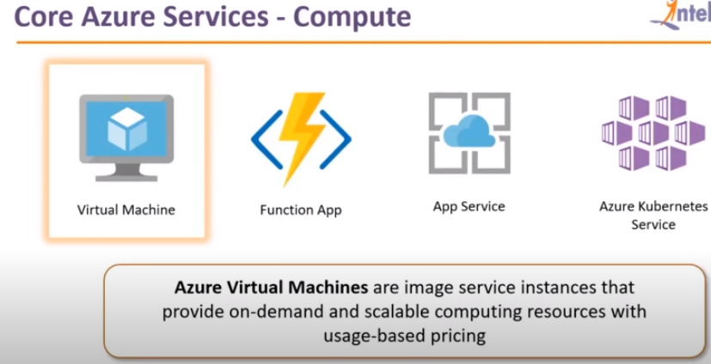

**Compute Services :**

Here we have 4 azure core services

Virtual machine, Function App, App Service and Azure Kubernetes services.

**Virtual Machine:** Its nothing but a computer just like a laptop which has just installed windows on it and nothing else in that . These are the machines which are provided by the cloud providers which in our case it is azure, they will launch it for you and they will give remote access for you , Its basically like working on a own laptop and working from remote location.

**Function Apps:**  It’s an advanced version of virtual machine, in which you won’t get the access of the operating system.

Example: You are working on website, and that website will do the processing for you . For example you are on face book and you want to upload a profile picture , before upload that you want to crop that profile picture to a particular size**.**

So some process needs to be on the picture before uploading it to FB, so these processing will done by backend servers.

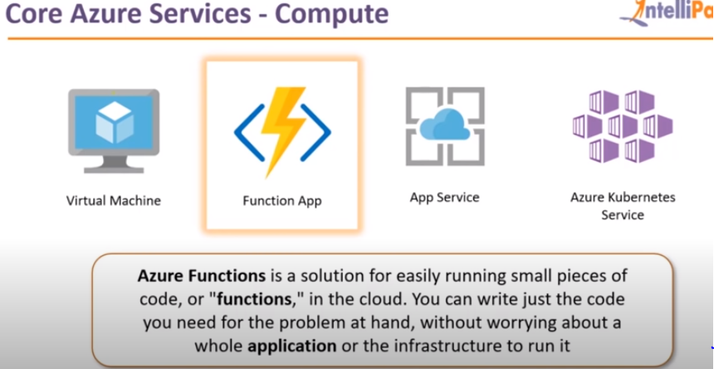

Face book have web servers in place and they separately have database server in place, for processing they have a separate server. That separate server is called back end server.

So on face book you have 100s of users who will be uploading the pictures , so the backend server will take care of the Image processing and the front end server which is web server will be serving the website of the user.

So there are 2 tasks happening over there.

Function App is nothing but a backend service on which you don’t have to deal with operating system , it will just give you the access to the dashboard where you can upload code , ad it will do it for you.

What and all you can do is give the code and see whether the application is running .

This kind of services which we called as PaaS (platform as a service) and earlier which we have discussed about Virtual machine and that is called IaaS (Infrastructure as a Service) why you are using the OS on that server .

In function App you need to just choose the environment where you can run the code and that’s all function App .

**App Service:**

It is yet another platform as a service, what you can with this App services is you basically launch or deploy the website, even function App looks similar but function App will give outputs based on Inputs.

Function App cannot deploy the web application for you , if you want to deploy the web application , you want to use Appservice , In App Service you find a resource called Web App and you have to deploy that and on that again you will get the dashboard since it is a PaaS there which you can upload your website files.

Once that is done , you will get a link and once you click on the link , you can see the website.

Here also you didn’t got the access to the OS.

Next service is the most important service Azure Kubernetes Service.

**Azure Kubernetes Service (AKS):** This is most important service if you works in a containerized environment.Docker is nothing but a containerized platform on which you can deploy applications , We are discussing about distributed computing , Containers will acts as separate virtual entities which are isolated from each other, I can launch an ubuntu container, I can launch an centos container, I can launch different flavor of Linux container, whatever code files I want , I can put on those containers , and these containers will interact and starting doing the computing.

Kubernetes will manages these containers , its an automatic service, lets example I deployed 3 containers, one is my website container, one is my backend container, one is my database container, for some reason my backend container is not working , it stops working , whenever my backend server stops working , we need to get an alert , so that we can see what is the problem is and then will fix it and then backend server will run normally, but the thing you cannot monitor the application 24*7.

Now what kubernetes will do is, it will do all the manual tasks for you. so it automatically detects that a fault has occurred in a particular container and it deletes the container and launches a new copy of it automatically , it is one of the tasks which kubernetes does for you , you also can configure the kubernetes to scale the container or rescale the containers for you .



**HANDSON:**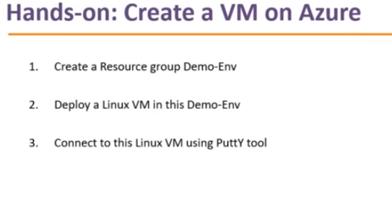

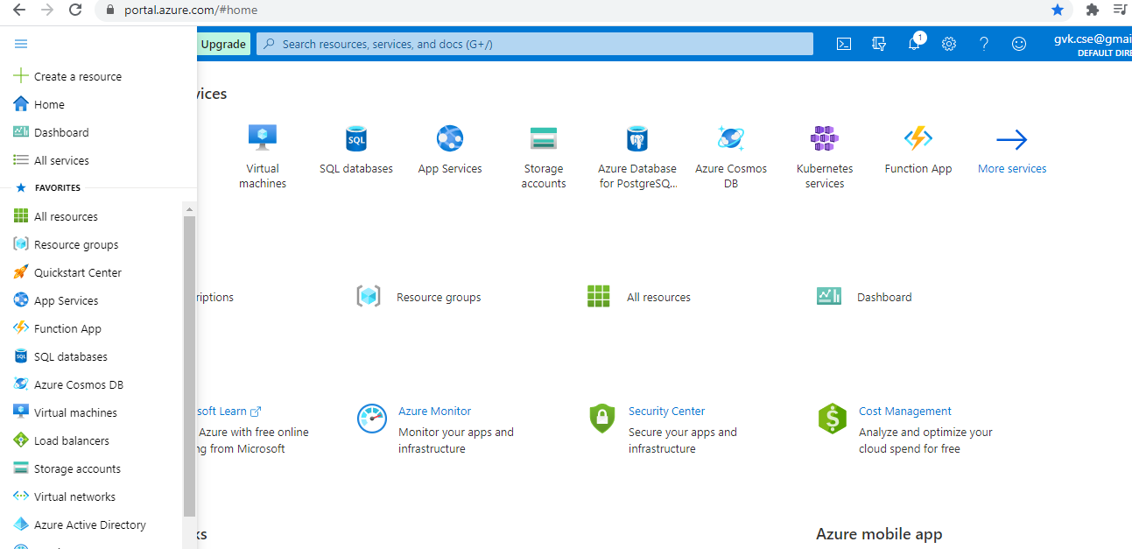

This is how the azure portal looks like .

Now we will see how we will deploy Linux VM in azure .

Will see how resource group will help us .

Now under home 🡪 click on Resource Group

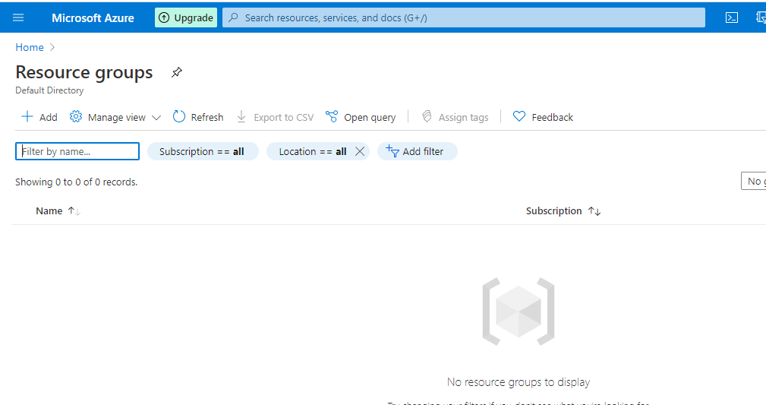

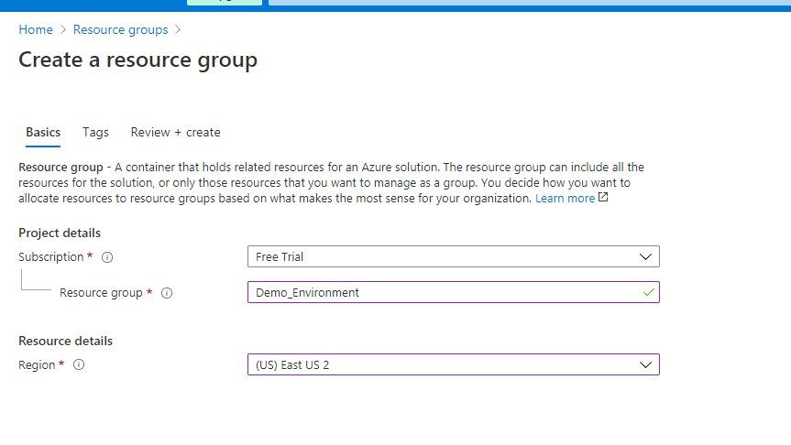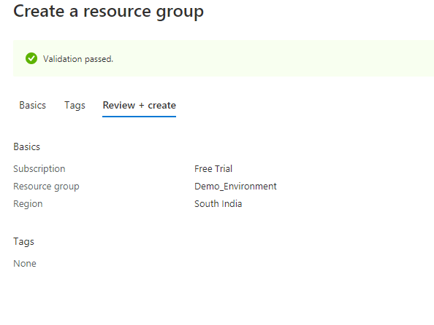

Click on create so that your resource group will be created.

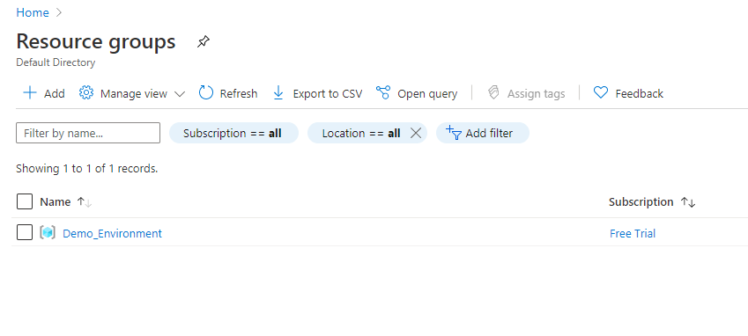

And its aa free trail .

***Step-2 :***

I have to deploy a linux VM in the demo Env .

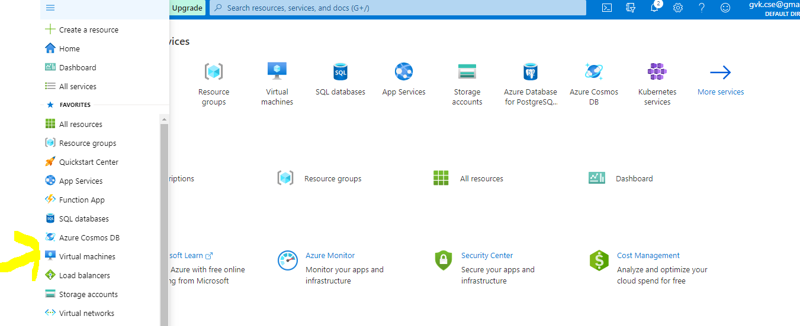

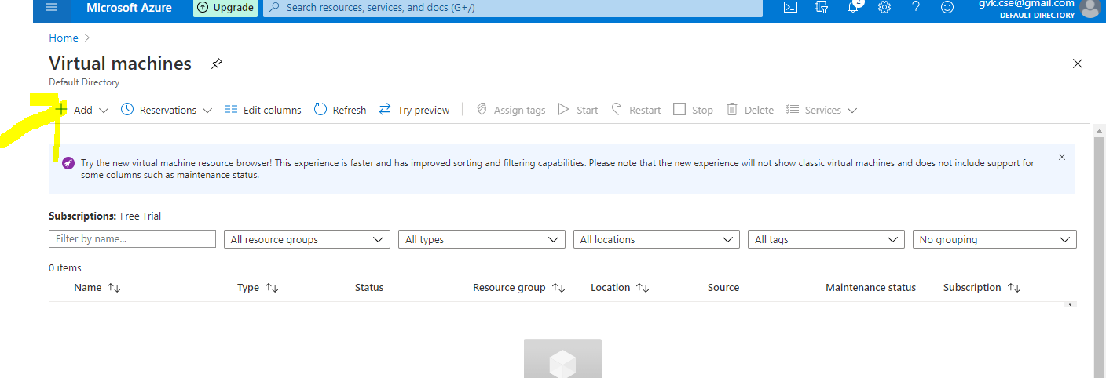

Then click on Add.

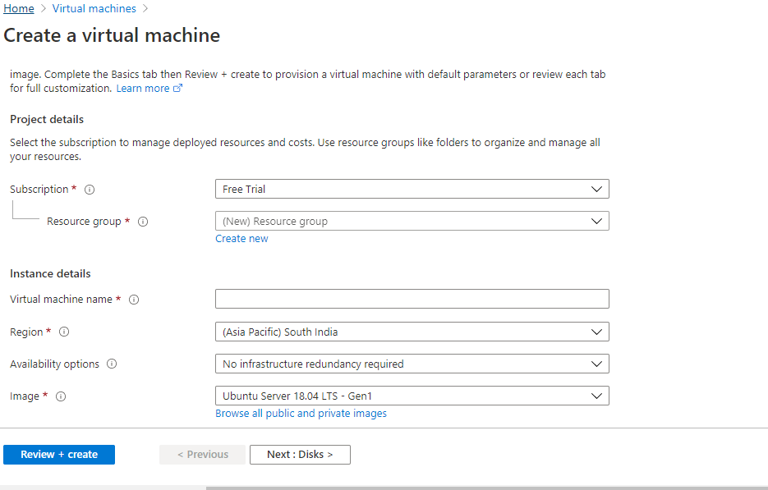

You will get the above window , key in the required details and add it.

Redundancy means if you want to have your copy of VM somewhere else, suppose you are going to launch your VM in a data center, suppose if that data center goes down , that point of time your Reduntant server will come into power and that is where you will get the data , it will increase the availability time of your application and even if there is a problem in the azure side the application ill not go down.

Even you can select the size of the machine.

You will authentication type 🡪 you can do it through password or you need to enrate SSH publick key ,

Mostly we will go for password authentication.

If you want to give security instance to your VM then you can go for public key .

You need to download putty Gen .

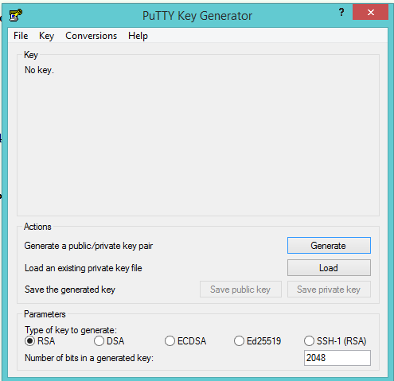

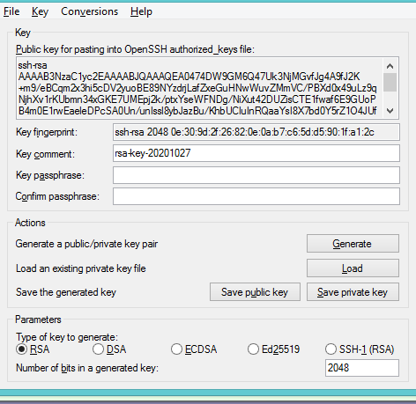

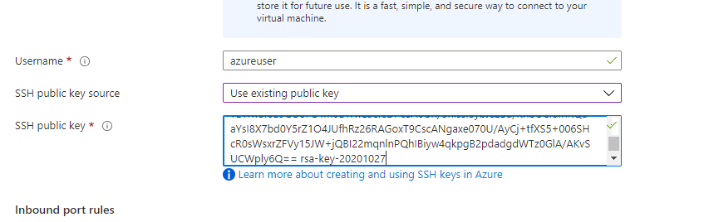

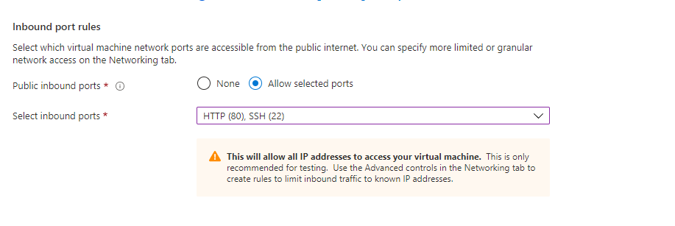

Once we launch the machine everything will be created .

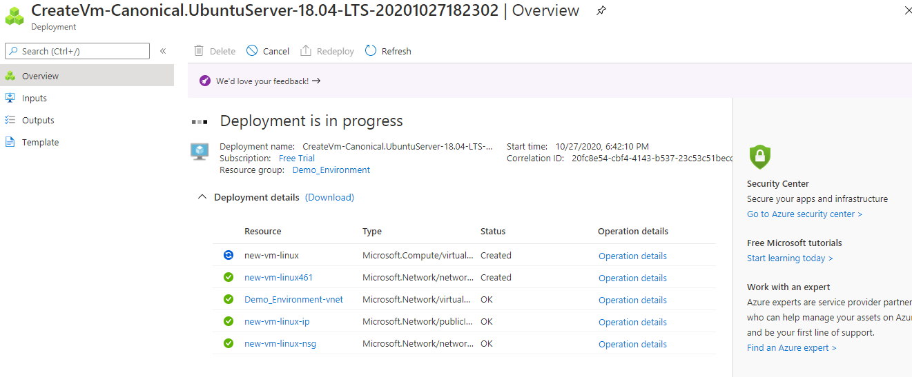

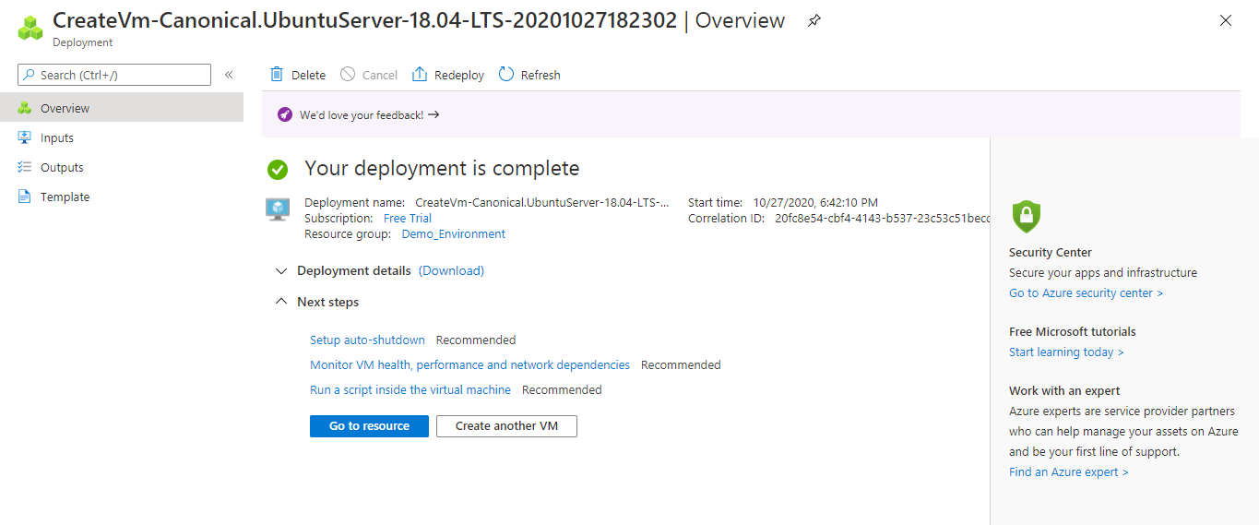

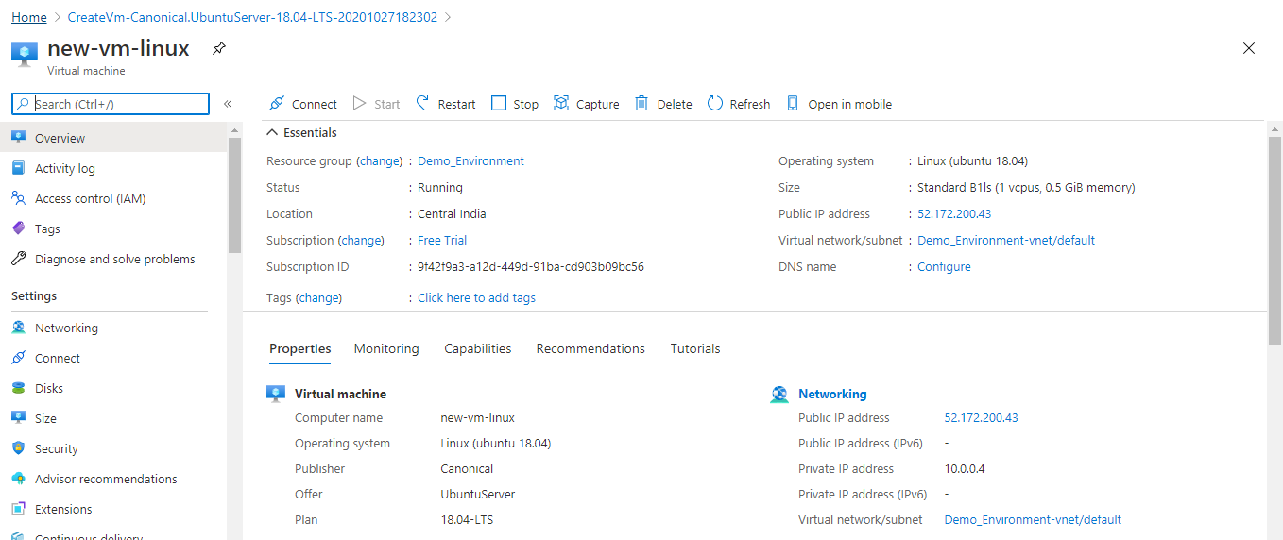

Now select the IP address.

Now download the putty and paste the IP address (publick Ip address) 🡪 go to SSH 🡪 Go to Auth 🡪 browse the private key location .

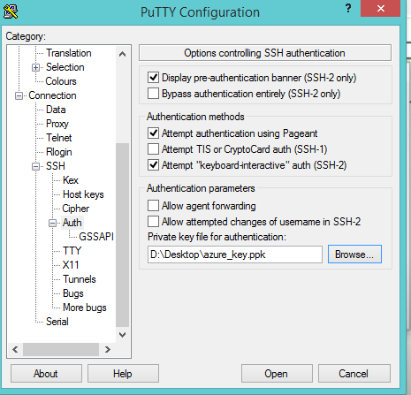

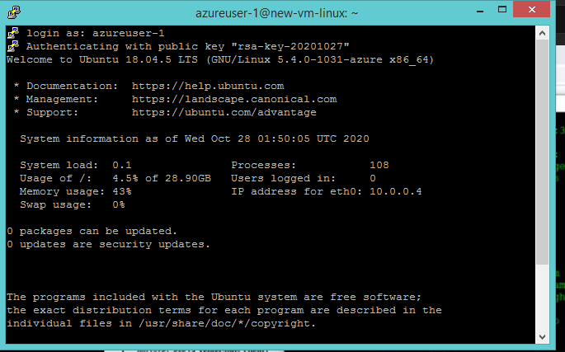

Now you are inside the linux machine which is ubuntu machine and now you can do anything .

I can make this server as webserver , inorder to do that .

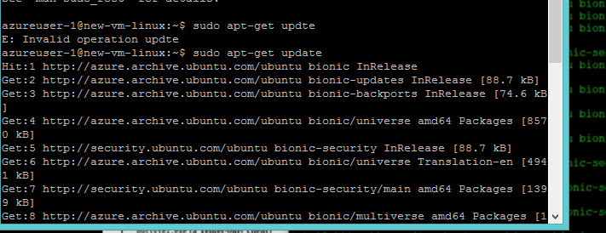

Apache is basically a software for webserver and now it is installed n ubuntu machine.

Its installed

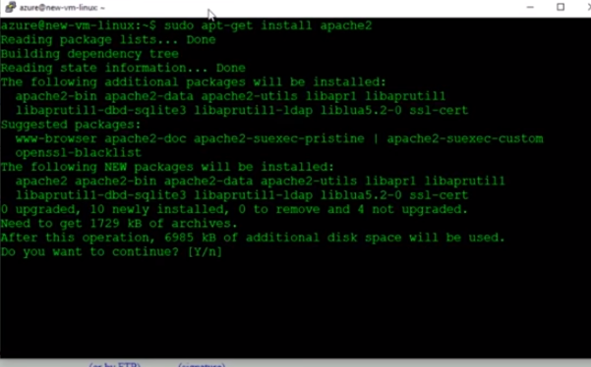

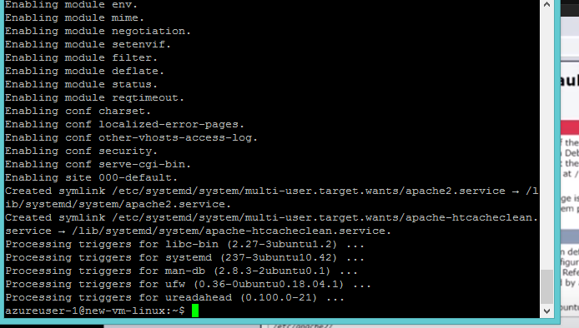

Now go to new tab.

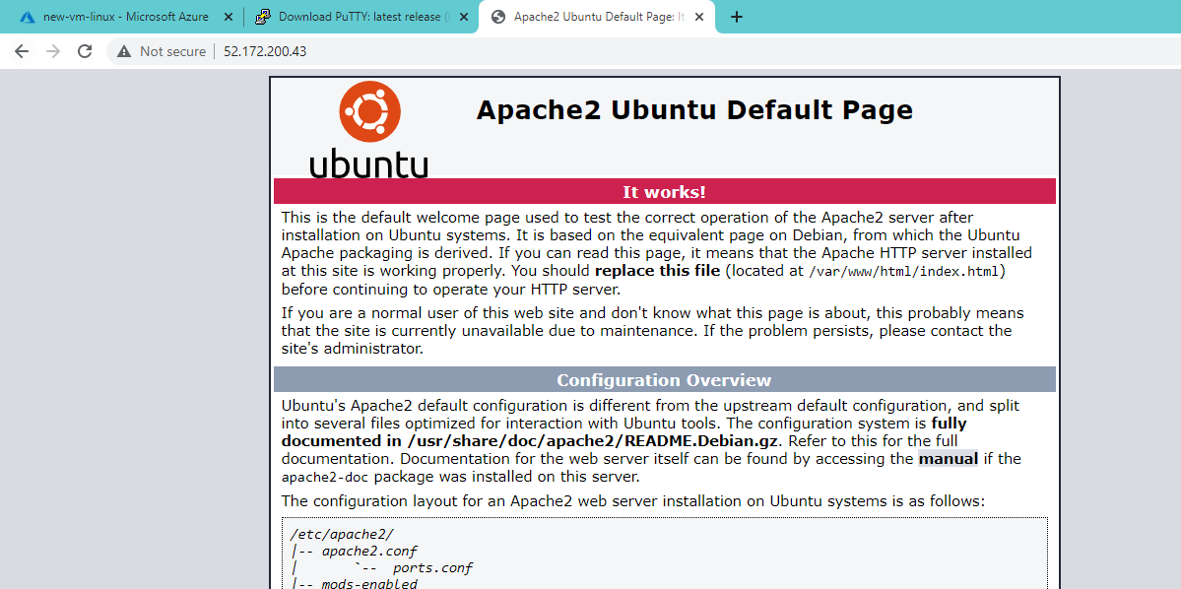

This is a website which was created by apache2.

**Networking Services of Azure :**

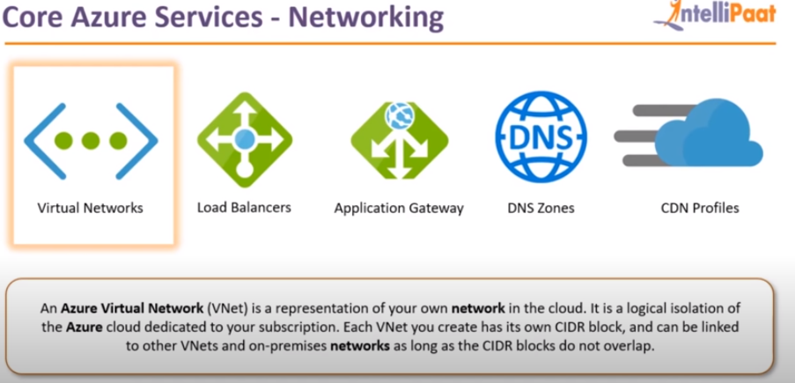

There are 5 services in this domain

1. **Virtual Networks:**

These are basically isolated environments or islated networks in the azure environment, whatever VMs you launched in azure , if you want that VMs to talk to each other , let us assume we have launched backend servers , a database server , if you want those servers to talk each other , how can they interact each other , they can interact with each other if they all are in one network, otherwise they need to connect over the internet which is not secure.

The entire power on these servers will be there with the admin who has launched those servers .

If the instances are connected over the internet , the bandwidth may go down .Whenever you want launch any resource in azure you need to do with in a virtual network.

Azure wont allow to launch the instances without using a virtual network.

1. **Load Balancers :**

This is also one of the important service, reason being when you deploy your application on a cloud, most important reason why we are deploying the azure is because you can get high availability .Means you can launch your application on multiple servers so that even if one server fails , the other server basically be the replica and can serve the application .

This results in the high availability of application .

1. **Application GateWay Load balancer :**

The next kind of load balancer is application Gate way load balancer , it works little bit different than normal load balancer , here the load is distributed among the servers based on rules, what are those rules? Those rules are basically paths , for example if we go to intellipat.com/blog , we can see the blogging website , if I go to intellipat.com/all-courses , we can see all the courses which is there in the website, We will have separate server for blogs and we will have separate server for courses , we will use application gate way load balancer , when it sees the request in URL as blogs , it basically routes the traffic to the blogging server. Whenever it sees the path is allcourses , the traffic will be routed to the all courses server.

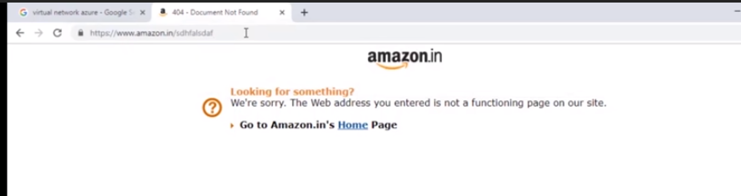

Whenever you give wrong uRL , you will get 404 page which is also specified in the path .

1. **DNS Zones :**

Normally when you enter to any website , you wont be giving the IP address of the website , you will be giving the domain name of the website that will take you to the website.

Similary in the case with DNS zones is well , what DNS zones helps you to route your domain to the azure resource where your application basically resides . Suppose you buy a domain which personal.xyz , now you want to route who ever going to this domain to your Virtual machine which you have launched in azure portal .

For that you need to go inside the DNS zones ,you will get some name servers, those name servers are basically DNS servers that azure owns and those DNS servers , so whoever is using personal.xyz those will be routed to those DNS servers that you will be mentioned in dashboard .

In the DNS zones service you will specify whenever requests comes to personal.xyz that has to be routed to the VMs.

1. **CDN service:**

This is the most important service which is called as Content delivery network.It basically improves the time taken to server you a website.if you go to amazon.com and see how much speed the page loads ith good internet connection. It loads very faster .

Let us take a website which of small scale , mostly 500 people will be visiting the server at a pount of time , lets take the server is in INDIA so people fro india can get the website very fast , but from other country it will take some time to get the website since it is from different region and data will go and then comes to INDIA server .

Hence In order to make the time fast , one thing is we can set up the data center in that particular country and other is using CDN, it basically cache the static data.

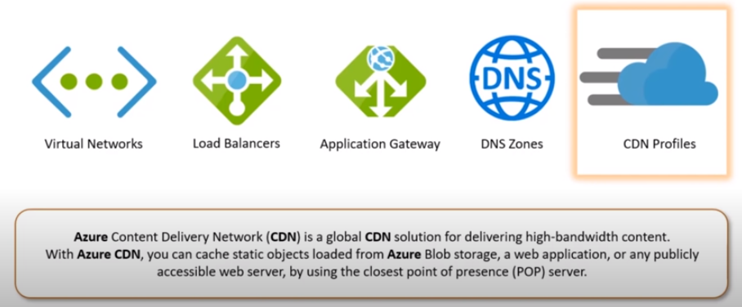

What is the static data , lets talk about videos , suppose your data center is at US and you are from japan , whenever you want to video on the website then what will happe means , that video gets downloaded to the nearest data center in japan in azure premises , if any other person tries to access the same video then that person can watch from japan server itself rather than US .Here what we did is we have enabled CDN in website.

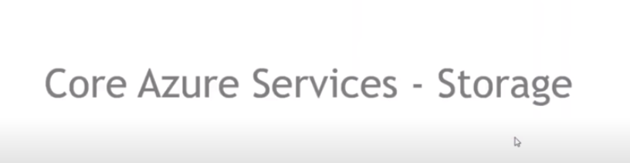

There are 6 services you should know about the storage services while you are using azure in terms of storage.

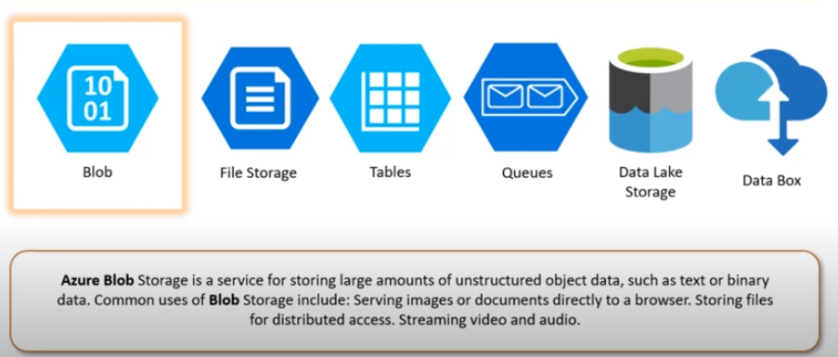

1. **BLOB :**

The full form of BLOB is binary large objects . If you have binary files and if you want to store them on azure , BLOB storage is the answer for you . It can store anything from music files, or it can store video files , it can also store text documents , any kinds of files .

BLOB can also be used with in conjustion with the websites which acts a storage server for you .

It also enables you to host content which is publicly accessible over a link and it can also host that webites on storage . Mostly MNC will place the static content on the BLOBs.

1. **File Storage :**

It is basically a shared file storage that can be used with multiple computers, means if we have 5 servers and they need a particular file for their working , all the file servers basically need the same file , what I can do is , I can basically create a drive , I can create a storage point on file storage and file storage drive will be mounted on them.

So a central storage has to be there for 5 servers so that everyone will be n sync with each other. Whenever there is a change of data in file all the servers will be aware of the change.

1. **TABLES:**

Azure table is basically a no SQL data store and it is helpful to store the structured data , It has tabular columns and tabular rows in which you can save data . It is no SQL in nature which means the data must not be in semetry , the 3rd row could have 8 columns , 4th row may be 2 columns , it can have any data but the only condition is the data should be structured among columns .

If you want to store this kind of data you can use azure tables.

1. **Azure Queues :**

This is used with stateless systems. Lets say there is a image processing website , the moment you give the image it will process the image according to your need, lets say there are 200 people on the website and all are processed the image processing button together , now what will happen is there are 200 images that will be processed , not all the 200 images will be processed at same time , the images are processed one by one , the backend server where the processing is done , lets say there are 5 backend servers , those will be picking the random images from the queue , its based on first in first out .

Whichever image comes first will go out first. Whenever the job of the first server is done , it picks up another image from the queue , second server will do the same ad 3rd server will do the same , first server has processed the image 1 but second , third and fourth server don’t know whether the first server has processed the image or not , and they can process it again , for those kind of scenerios we have queues which basically streamline all the content which has to be processed , which ever image is processed that will be deleted from the stack , will put another image which has to be processed.

1. **Data lake Storage:**

Azure Data lake Storage is similar to that of azure tables, it can store data but it is basically used to store the data for big data analytics.

It specializes in that core segment , if you have big data analytic use case , and if you want to store the data for that , data lake storage will be choice for you .

1. **Data Box:**

Lets take you are working on a company and all the servers are on premise,now you want to migrate all your applications to azure.

Let assume you need to transfer 5PB of data and time is very important , everything needs to done in a fast phase , Hence it takes lots of time to transfer such huge amount of data to azure, in this case what azure does is , it basically gives a physical device on which you can load the data , Azure data box is a service where you can physically request the box kind of a system from azure where we will load all the data on it , then that box is shipped back to azure cloud and again all the data is uploaded to azure cloud from their to data center directly.

This not only reduces time taken to transfer the data , but it also reduces the cost to a larger extent in the internet charges .

Azure Data box can support 5PBs of data at one time.

If 5PB is less for you , you can request multiple boxes from azure , so that PBs of data will be transfredd less than a week and you cn save huge amounts of data.



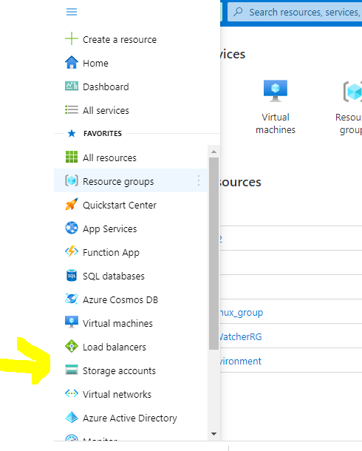

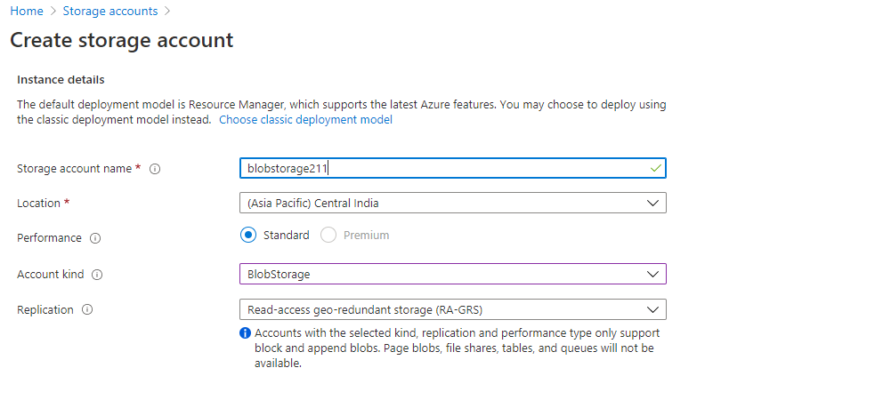

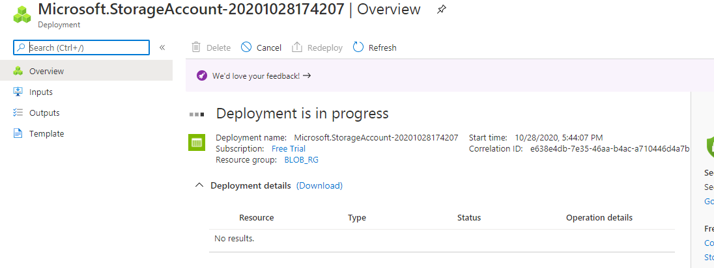

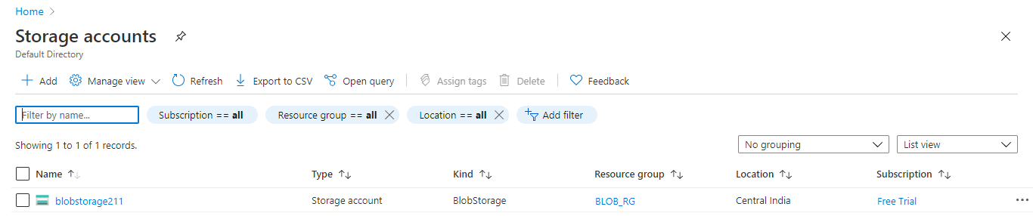

You can see storage account is created.

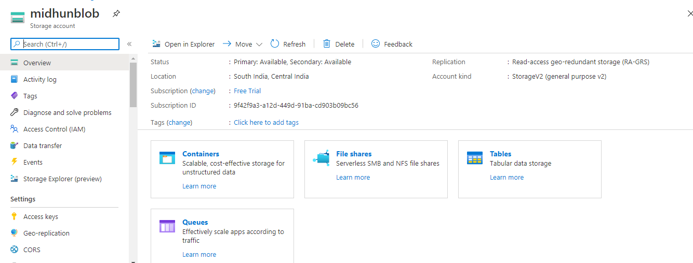

Containers are nothing but root folders.

On windows , you have desktop folder, that is a root folder .

Try to create the new container .

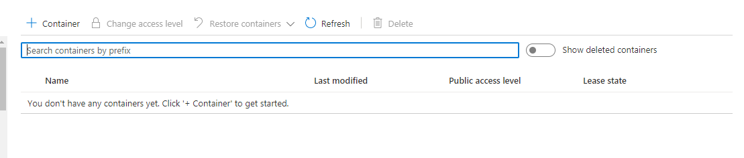

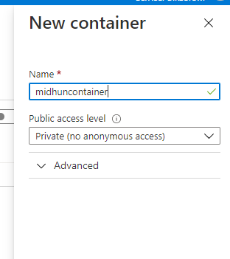

Now my new container will be created.

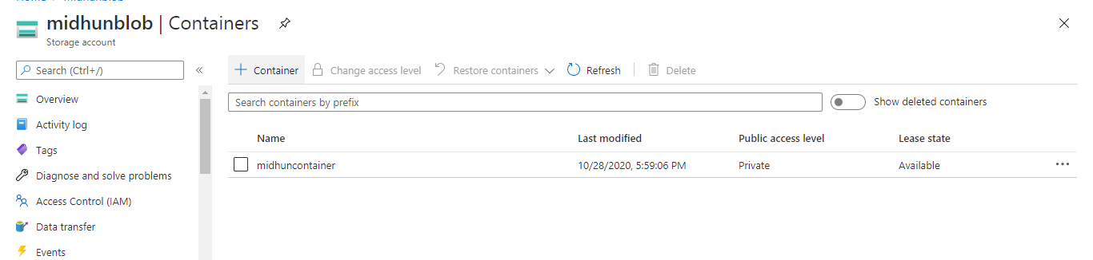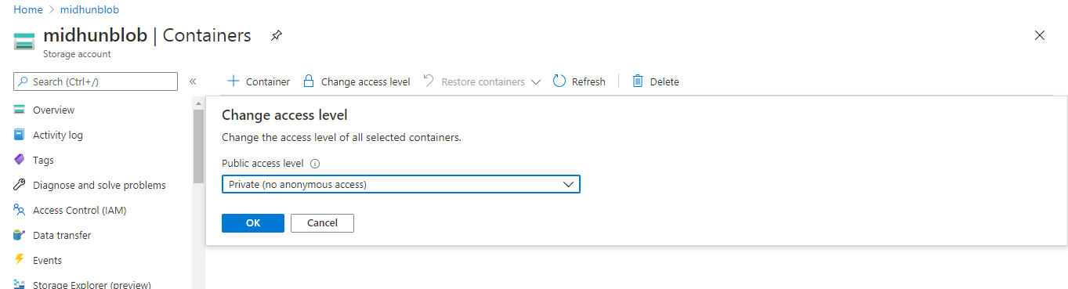

You can there is a access level , you can change the access level.

If you go inside the container , you can see there is no BLOBS found.

Now upload the image inside the container by browse .

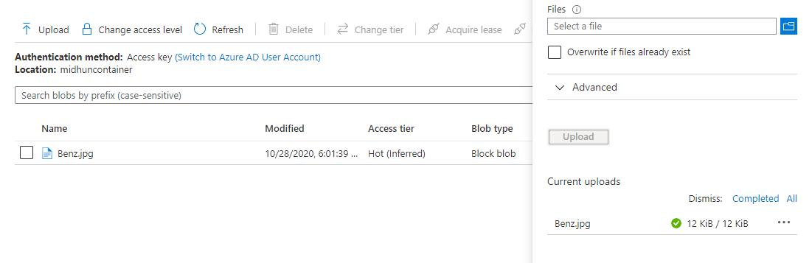

You can view the details in the BLOB

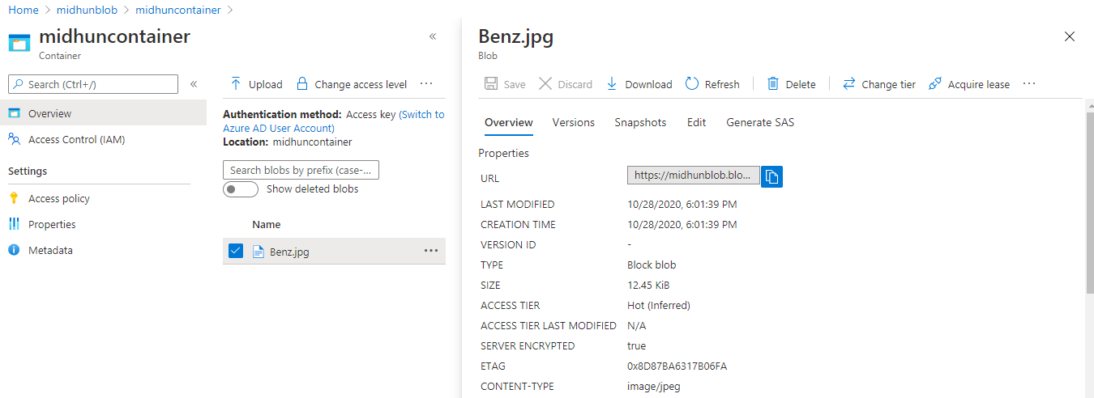

When we try to access the URL , we will get the below error .

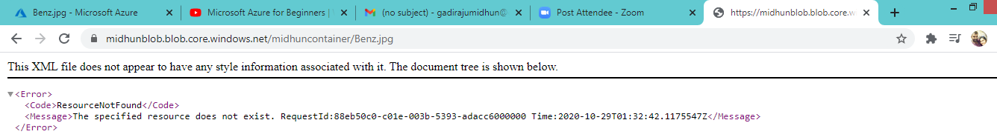

Because we didn’t given access to general public use .

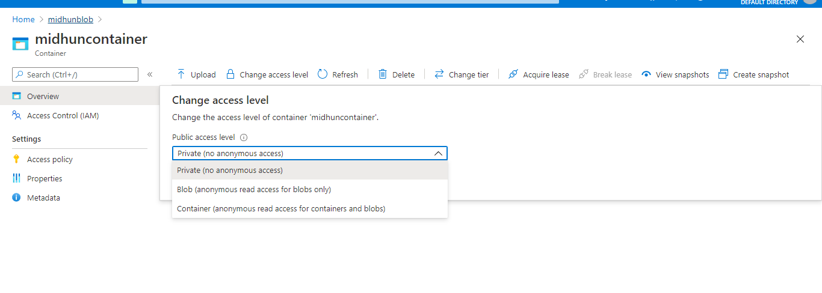

Select BLOB (Anany) and change the access.

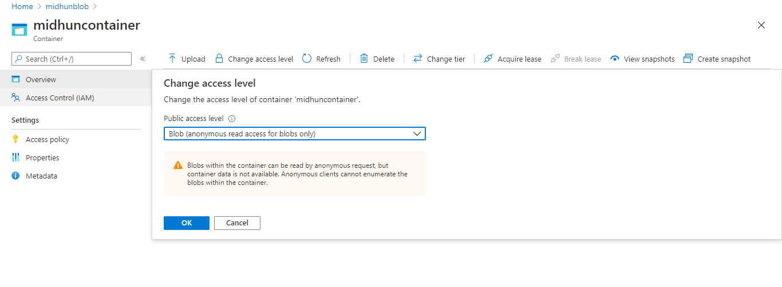

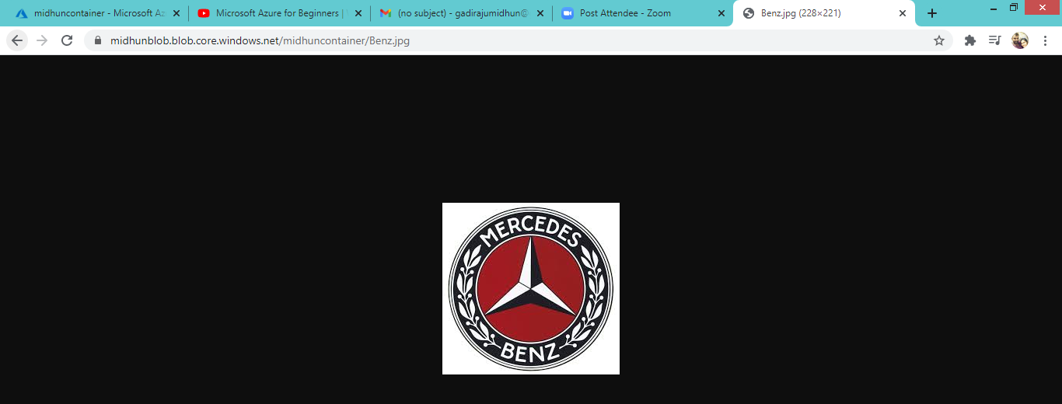

Now you can see , the image is browsed.

You can use BLOB storage to dump data.

How to add the table :

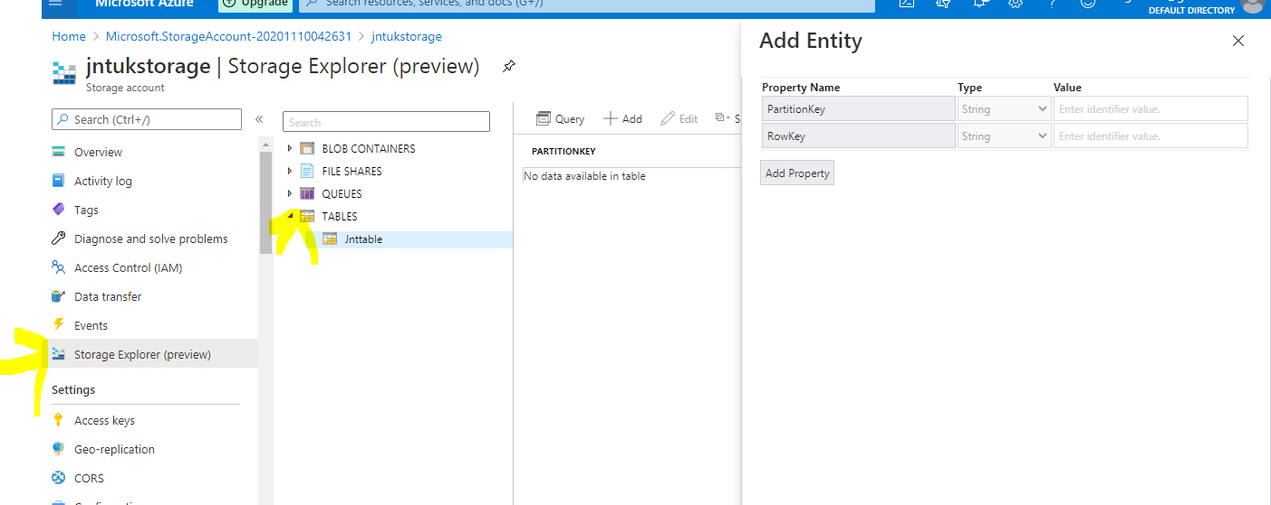

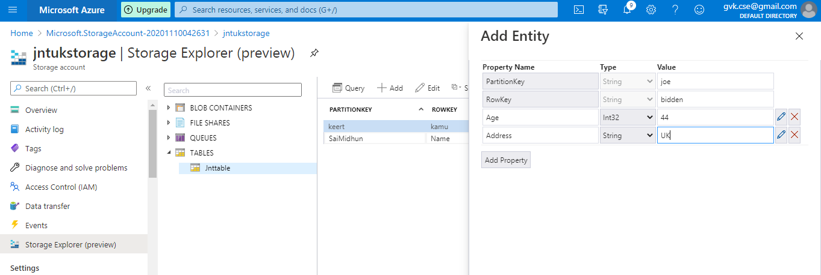

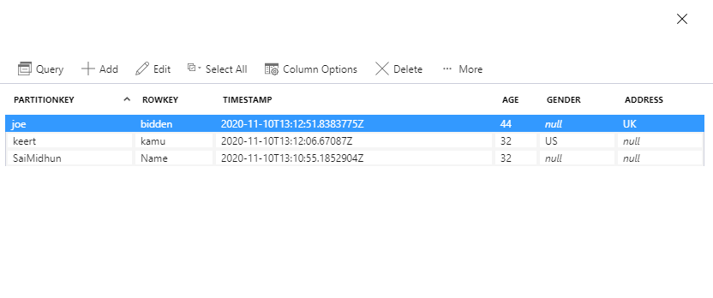

This is a NOSQL , hence its dynamic schema model.

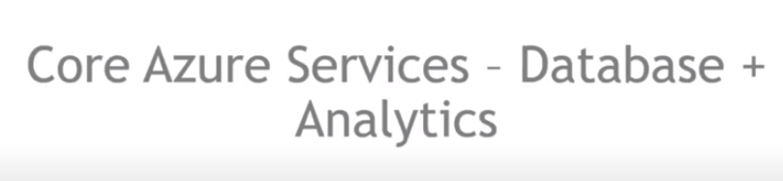

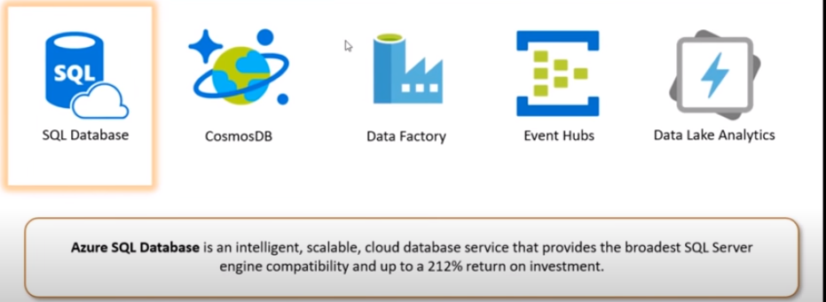

1. **SQL database :**

The first service is the SQL database which is basically database as a service, you don’t get the access to the OS , on which this Database is installed. You will get access only to the database. It won’t access to the operating system , but gives access to the platform kind of thing , where you can interact with service and upload something to the software being used called PaaS.

1. **COSMOS DB:**

It is fully managed SQL service again, here your DB is extremely highly available, which means it is distributed throughout the world using azure regions .

When you launch a cosmos DB cluster, it distributes or create a replica of the Database on multiple regions as you specify , and the mai thing about this whatever region you want to close and want to stop and you don’t want your database to be replicated in a particular region, you can do that with click of a button.

The whole control is at one central place , and you can replicate your db at one platform , cosmos DB dashboard you will get You can implement master replicatin , you can implement write regions replication here.